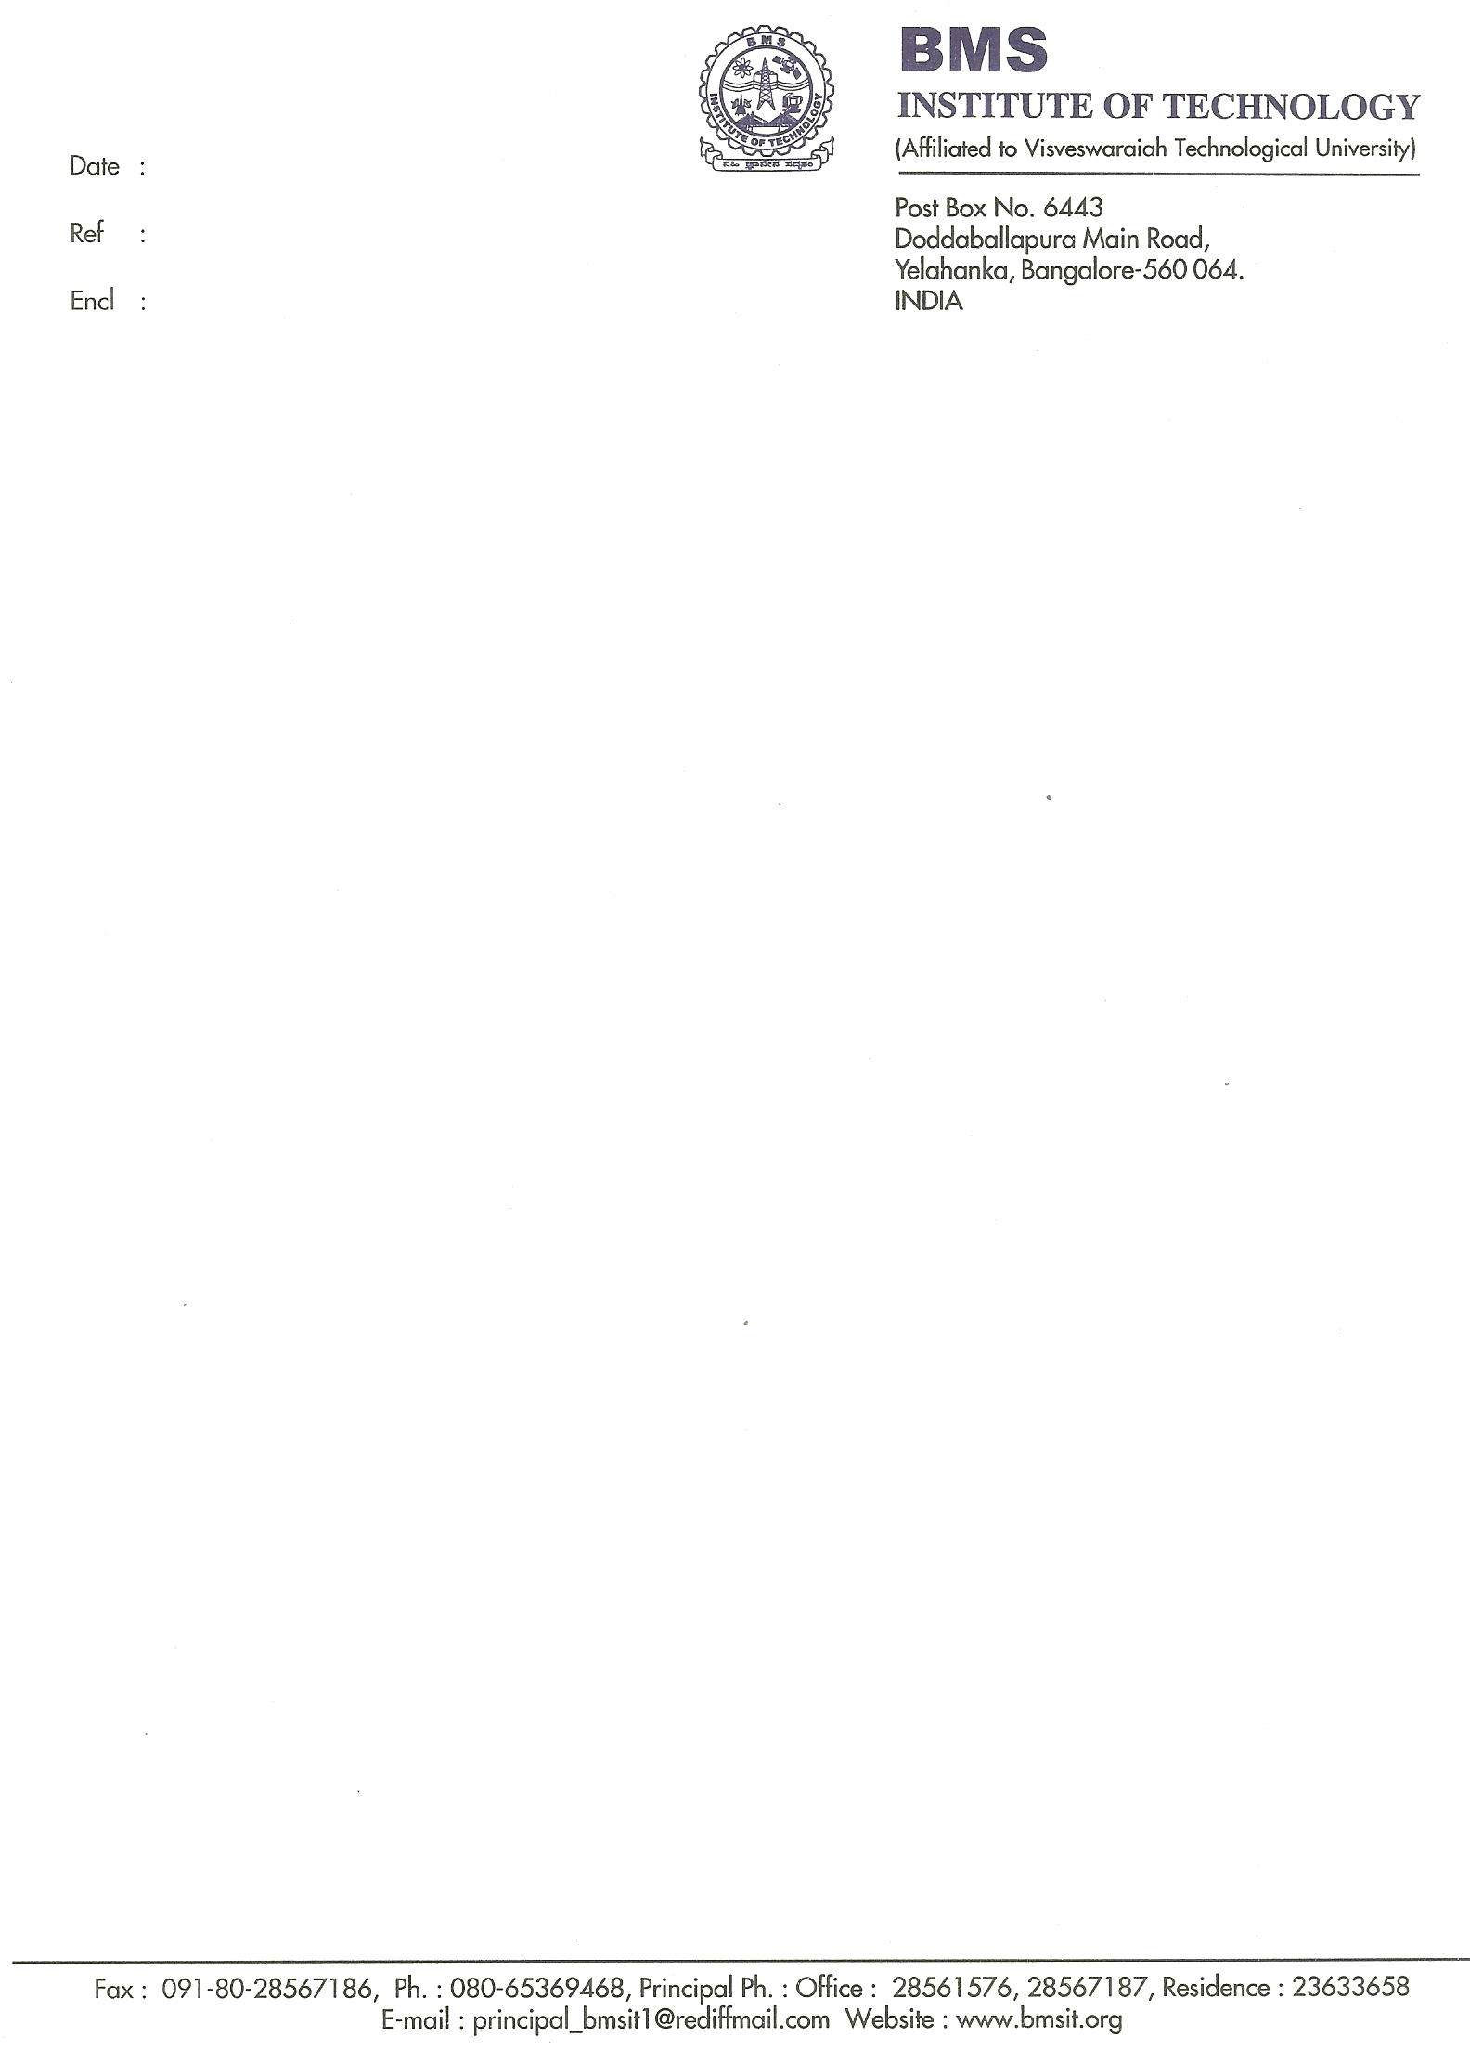

15/02/2011

Letter of Recommendation

Mr. Venkatesh Kulkarni is an extraordinary student. As his Mathematic Professor, I have seen many examples of his talent and have long been impressed by his diligence and work ethic. I understand that Venkatesh is applying to the masters program at your esteemed university. I would like to recommend him for admission.

Venkatesh has outstanding organizational skills. He is capable of successfully completing multiple tasks with favorable results despite of deadline pressure. I must also make note of Mr. Venkatesh had exceptional academic performance and was the topper in 3 semesters. In the college of around 300 students in 2008 batch, he has engineered with honors in the top 10%. His above-average performance is a direct result of his hard work and strong focus.

If your master program is seeking superior candidates with a record of achievement, Mr. Venkatesh Kulkarni is an excellent choice. He has consistently demonstrated an ability to rise to any challenge that he has faced.
To conclude, I would like to restate my strong recommendation for Mr. Venkatesh Kulkarni. If you have any further clarifications regarding Mr. Venkatesh or this recommendation, please do not hesitate to contact me using the information on this letterhead.

Sincerely,
Chethan A.S
Professor, Dept. of Mathematics
B.M.S. Institute of Technology
E-mail: as.chethan@gmail.com

